
PIR Motion Sensor Tri-Tech Motion Sensor

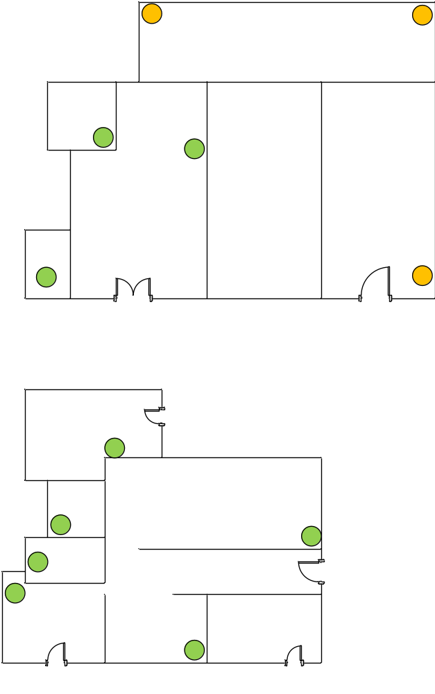

Customer Name | Analytical Instrument (Charter House)
Drawing Title | IDS
Issue No | RE/TE
Issue Date | 20/7/2018
Revision No
Revision Date
Created By | Ajith Fernando
Approved By

